Guide for creating diferent smart aim settings for weapons
this guide covers thew basic functionalty for creating a simple smart aim data asset for weapons
Weapons in toaster arena can have diferent secondary fire modes that activate when the user presses mouse 2
Some weapons can shoot twice and others can aim
Weapons that aim use a data asset for aiming, by using data assets, such functionality can be re-used for multiple weapons

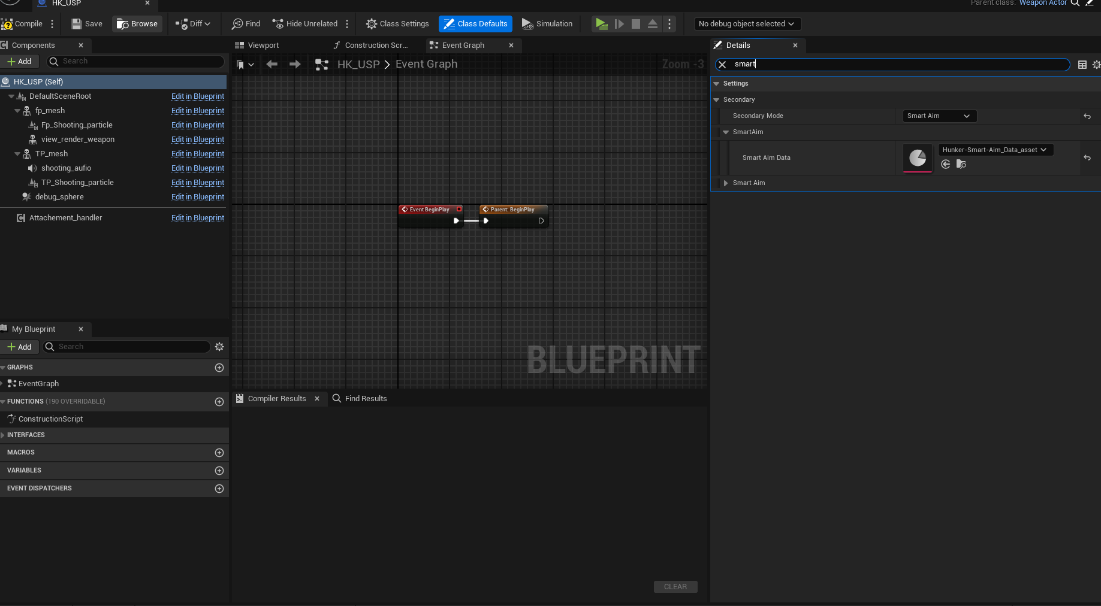
The data asset can be specified by going in to the weapon blueprint and choosing a compatible data asset
(in the picture above, the selectedf weapon is the hk pistol and selected smart aim asset is called Hunker-Smart-Aim_Data_asset
Each weapon can have it's own data aasset but for now, all of them share the same one

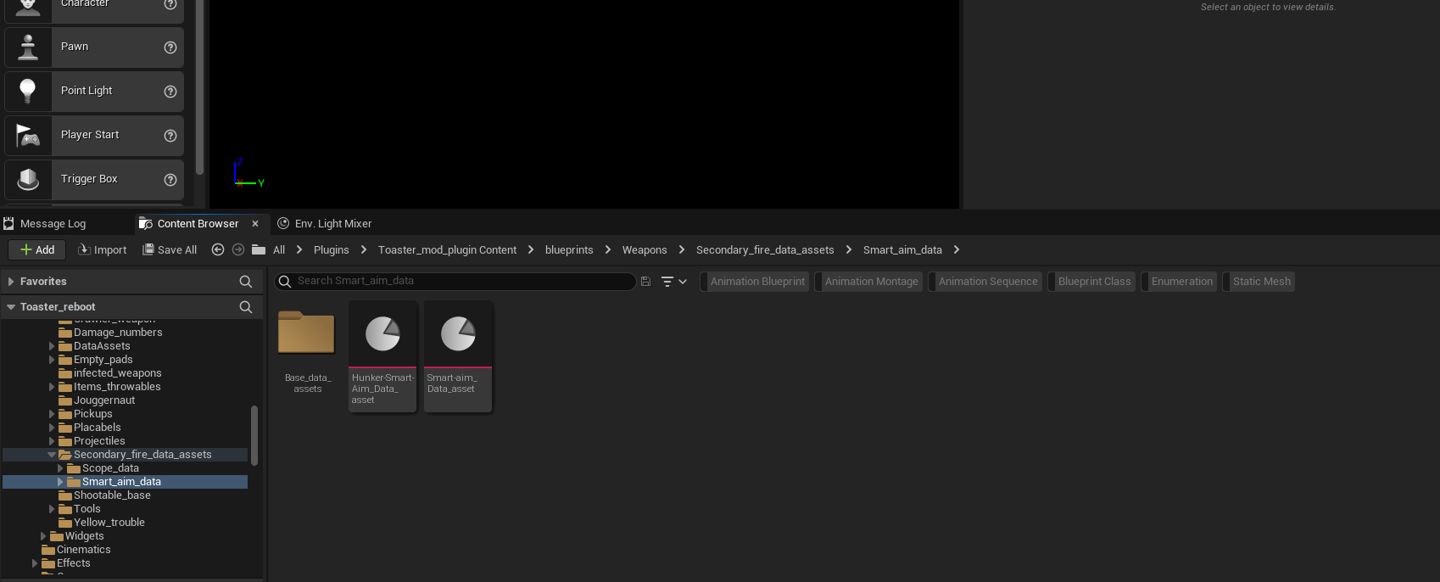
Data assets can be found on this location
Data asset variables are self explanatory

